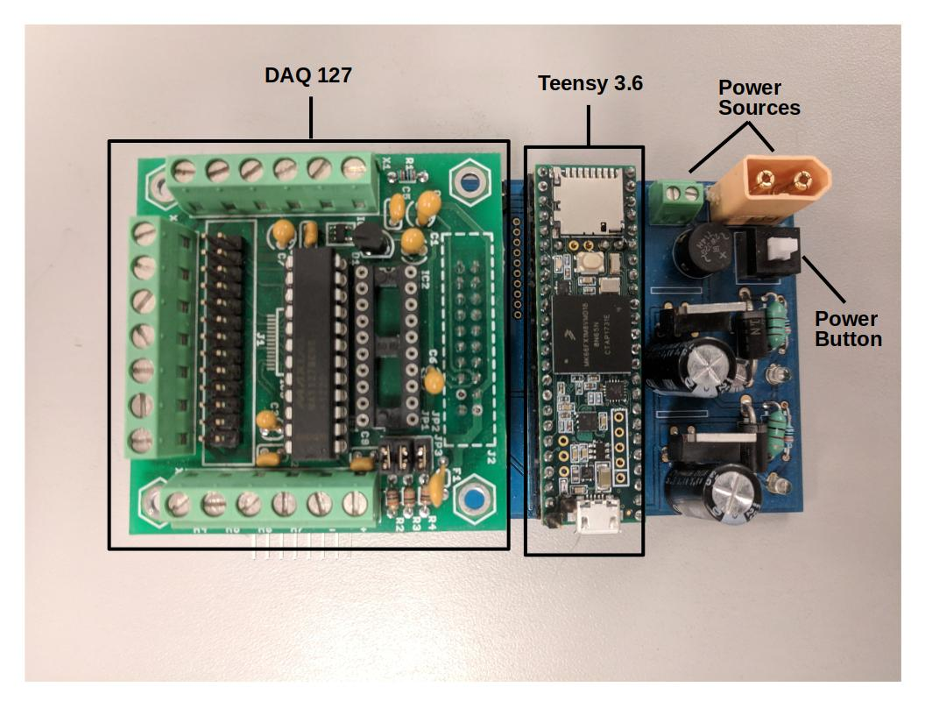

**DAQ User Manual**

Neuromuscular Control and Human Robotics Laboratory

Last Updated By: Tanner Bitz

Last Updated Dated: July 27th, 2018

**Hardware**

This data acquisition (DAQ) unit consists of a few essential elements. They are:

1. Teensy 3.6

- This the microcontroller that runs everything on the DAQ

2. DAQ127

- This piece of hardware takes 12 bit analog to digital measurements in any of it’s 8 channels. It also has an expansion connector (J2) on top that can be used for additional I2C device connections.

For more information about the DAQ127, the datasheet is located at:

<https://www.bipom.com/documents/peripherals/daq127_128_2543.pdf>

The microcontroller that runs the DAQ127 is the MAX127. It’s datasheet can be found at:

<https://datasheets.maximintegrated.com/en/ds/MAX127-MAX128.pdf>

3. Power Sources

This board must be supplied with 12V. This can be done using either of the power source connectors shown in the picture above.

4. Power Button

This must be pressed down to power the board after the power is hooked up to the power source connectors.

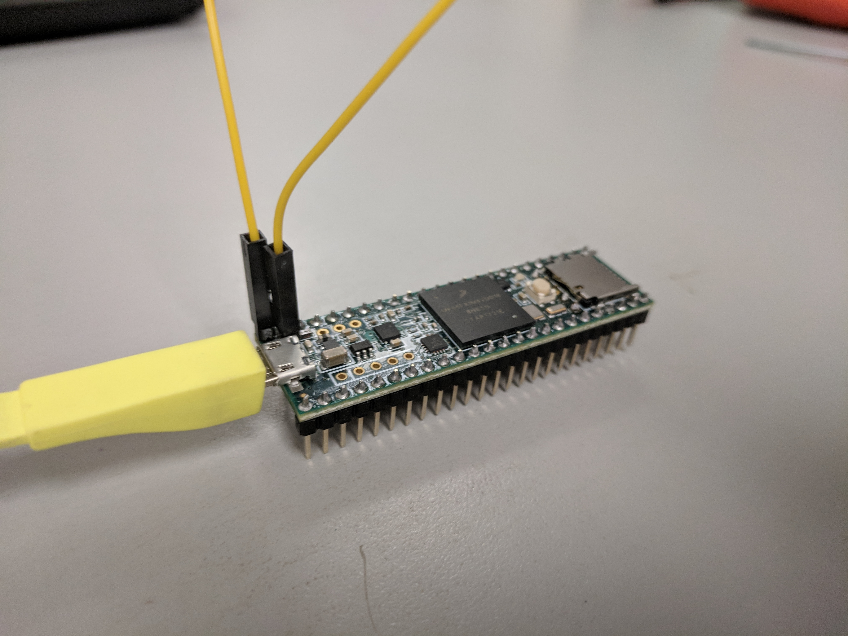**Programming**

**To program the DAQ, the Teensy 3.6 must be removed from the board**. Be careful not to bend any of the pins during the removal process! This can be difficult sometimes as it is a very tight connection. Please be patient when removing it.

As of the writing of this document, this microcontroller is being programmed with the Arduino IDE. **To interface the Teensy 3.6 with the Arduino IDE, the program Teensyduino must be installed on your computer**. It can be found here: <https://www.pjrc.com/teensy/td_download.html>

Once Teensyduino is installed on your computer, the board should be listed in Arduino under the menu Tools→Board→Teensy 3.6

Next, **connect the 2 pins soldered on top of the Teensy with a jumper cable**.

Then **connect it to your computer with a micro USB cable**. The Teensyduino software should automatically open if the Teensy is connected, Arduino is open, and the board is chosen in the Arduino IDE. **Press the white button on the Teensy.**

**If you followed all these steps, it should now be in programming mode.**  To test whether it’s in programming mode, I suggest you try the Blink sketch in the Examples.

**Designed Use**